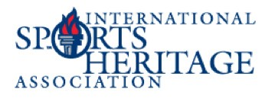
WW W.SPORTSHERITAGE.ORG
ISHA SILENT AUCTION

September 26-27, 2018 | Santa Clara, CA

We are looking for items that have universal appeal, as well as appeal to the sports fans. If you can donate, please make your donation early in order to be listed in the conference handbook. We are asking that all donations have a minimum value of $50. If you have any questions, please contact Dana Hart at dhart@wbhof.com.

Restrictions:
I will make the following donation to the ISHA Silent Auction:
Exclusions: Expiration Dates:

Retail value of item $
Name Organization Address City State Zip
Phone Number
Email Address:
Signature
PLEASE MARK YOUR ITEM “FOR THE ISHA AUCTION”
Please return this form by fax to (865) 633-9294 or e-mail it to Dana Hart at dhart@wbhof.com

Ship your item to
49ers Museum, Attn: Beth Atlas
4900 Marie P. DeBartolo Way
Santa Clara, CA 95054

