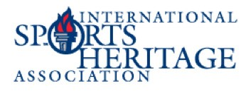
Donate to:
WW W.SPORTSHERITAGE.ORG

ISHA SILENT AUCTION

September 26-28, 2023 | Daytona Beach, FL

We are looking for items that have universal appeal, as well as appeal to the sports fans. If you can donate, please make use of this form to provide all details about your item and donation.

I will make the following donation to the ISHA Silent Auction, item description:

Restrictions:
Exclusions: Expiration Dates:

Retail value of item $

Organization Name: _______________________________________________________
Name: ____________________________________________________
Address __________________________
City: ___________________________________ State: _________ Zip: _____________
Phone Number: ____________________________________
Email Address: _____________________
Signature: _____

Please return this form along with a photograph of the item by email to:
Kent Sturman, ksturman@prorodeo.com
If you need to ship your item, please address as follows to arrive by Sept. 25:
Motor Sports Hall of Fame of America
Attn: Rhonda Geib (ISHA Auction)
1801 W. International Speedway Blvd.
Daytona Beach, FL 32114

